**Streamlining Academic Ecosystems with Edubridge**

*Kashish Tyagi*

*Computer Science Department*

*KIET Group of Institutions* Delhi NCR, India

[*Kashish.2125cs1193@kiet.edu*](mailto:Kashish.2125cs1193@kiet.edu)

*Dewansh Gupta*

*Computer Science Department*

*KIET Group of Institutions* Delhi NCR, India

[*dewansh.2125cs1141@kiet.edu*](mailto:dewansh.2125cs1141@kiet.edu)

**Abstract:*-*** **The modern educational landscape is characterized by a plethora of academic activities scattered across various platforms, leading to fragmentation and difficulty in accessing pertinent information. "Edubridge" is proposed to address the lack of centralized information about academic activities. The project aims to provide a unified platform that aggregates information about events, seminars, competition, projects, and announcements. The problem statement revolves around the challenge faced by students, mentors, and educational institutions in accessing and managing academic activities efficiently. Despite the abundance of educational resources and activities available online, there is a notable absence of a unified platform that consolidates this information, leading to confusion and inefficiency. Edubridge seeks to streamline the process of discovering, participating in, and managing academic engagements for students, mentors, and institutions. Key features include a comprehensive database of academic activities, a user-friendly interface, personalized recommendations, and collaboration tools for students and mentors. The implementation of Edubridge will follow a phased approach, encompassing requirements gathering, design, development, testing, deployment, and ongoing maintenance. Through iterative feedback and continuous improvement, Edubridge aims to evolve into a robust and indispensable tool for the academic community. The problem statement revolves around the challenge faced by students, educators, and educational institutions in accessing and managing academic activities efficiently. Despite the abundance of educational resources and activities available online, there is a notable absence of a unified platform that consolidates this information, leading to confusion and inefficiency. In conclusion, Edubridge represents a promising solution to the challenge of fragmented academic engagement by providing a centralized platform that fosters collaboration, enhances accessibility, and promotes meaningful interactions within the educational ecosystem.**

**Keywords:** Unified platform**,** Academic activities, Mentors, Educational Institutions, Collaboration, Accessibility, Personalised recommendations, Engagement, Centralised information.

**INTRODUCTION**

In today's digital age, education is undergoing a significant transformation, with online resources and virtual platforms becoming increasingly prevalent. Institutions worldwide are leveraging technology to facilitate learning, streamline academic management, and enhance student engagement. However, despite the proliferation of digital tools and resources, a critical issue persists: the lack of a centralized platform for managing and accessing information about academic activities.

The current educational landscape is often fragmented, with announcements, events, seminars, competitions, and academic resources scattered across multiple platforms, emails, and websites. This dispersion creates challenges for students, mentors, and educational institutions alike. Students struggle to stay updated on opportunities that align with their interests, mentors face difficulties in managing and guiding their students efficiently, and institutions find it cumbersome to promote and track academic engagements effectively.

The absence of a unified solution not only leads to inefficiencies but also undermines the potential for meaningful academic collaboration and engagement. As educational institutions continue to embrace digital transformation, there is an urgent need for a system that consolidates academic information and simplifies its management, thereby fostering a more streamlined and interactive learning environment.

To address these challenges, **Edubridge** emerges as an innovative platform designed to centralize and optimize academic activities management. By integrating cutting-edge technology with user-centric design, Edubridge seeks to bridge the gap between dispersed academic information and the need for streamlined access. This platform is envisioned to serve as a comprehensive academic hub, enabling users to discover, participate in, and manage academic activities from a single interface.

Through features such as a centralized information repository, AI-powered personalized recommendations, and collaboration tools, Edubridge aims to revolutionize the way academic activities are accessed and managed. With its intuitive interface and phased development approach, the platform aspires to create a cohesive and interactive academic ecosystem, enhancing efficiency and engagement for students, mentors, and institutions alike.

This introduction sets the stage for a detailed exploration of the Edubridge project, delving into its objectives, technological framework, and potential impact on the educational ecosystem.

**LITERATURE REVIEW**

This paper traces the history of ERP systems, from their inception in the 1970s to modern trends like cloud-based deployment, AI integration, and mobile accessibility. Key challenges include outdated practices, leadership gaps, and data security issues. It advocates thorough project planning, user training, and scalability strategies to overcome these hurdles. The study provides organizations with insights to optimize ERP implementations effectively[1].  
Through a systematic literature review, this study identifies critical success factors (CSFs) for ERP implementations, highlighting challenges like cost overruns and resistance to change. It stresses the importance of context-specific strategies, strong planning, and resource management to achieve project success. The findings offer actionable insights for organizations navigating ERP complexities while maximizing their benefits[2].  
This paper examines how e-government platforms can improve the integration of resources for student employment. It introduces the "S-S-G" model, analyzing government policies, university services, and alumni networks to support employability. The study identifies pathways for streamlining efforts between stakeholders to enhance employment opportunities for students[3].  
The paper explores the role of Common Service Centers (CSCs) in promoting entrepreneurship and e-governance in rural India. It evaluates the project's achievements, such as enabling digital services and boosting local businesses, while addressing bottlenecks like infrastructure gaps. Recommendations include better policy support and expanded reach to enhance rural development[4].  
This study details the development of an e-learning platform using open-source tools, focusing on cost-effective and adaptable solutions. It highlights how e-learning transcends traditional classrooms, leveraging technology for accessible, flexible education. The paper emphasizes the advantages of open-source software in fostering innovation in e-learning systems[5]. Investigating Enterprise Information Portals (EIPs), the study examines their impact on e-business performance. Key findings include the significance of integration, organizational size, and function application degree in driving success. It provides insights into optimizing EIPs for real-time business operations and decision-making[6].  
This paper surveys student satisfaction with university web portals, revealing high levels of approval linked to system usability, content quality, and ease of access. It identifies gaps for improvement and underscores the role of well-designed portals in enhancing the e-learning experience[7]. Analyzing e-government adoption in Macao, the study identifies trust, perceived usefulness, and persuasion as significant drivers of service usage. Surprisingly, ease of use and technology features had limited influence. The findings suggest targeted improvements to increase citizen engagement with digital services[8].  
This paper highlights the crucial role of user involvement in ERP system implementation to address technical and organizational challenges. User participation fosters better system design and acceptance, mitigating risks of failure. It emphasizes the need for active engagement to enhance ERP project outcomes[9].

**PROPOSED METHODOLOGY**

Proposed Methodology The implementation of Edubridge involves several key steps and activities to realize its objectives and scope effectively. The proposed methodology outlines the approach to be followed in developing and deploying the platform. Needs Assessment: Conduct surveys, interviews, and focus groups with students, mentors, and institutions to gather requirements and preferences. Analyze the data to identify common pain points and needs. Platform Development: Assemble a multidisciplinary team including developers, designers, and education specialists. Utilize agile development methodologies for iterative improvements. Content Curation: Collaborate with educators to identify key learning materials and resources. Develop mechanisms for ongoing content updates and quality assurance. User Testing and Feedback: Gather feedback on user experience, functionality, and feature preferences. Iterate on design and functionality based on user input. Scalability and Sustainability: Evaluate the scalability of the platform architecture and infrastructure. Develop a growth strategy to expand the platform to additional institutions and users. Explore revenue models such as subscription fees, partnerships, or grants to ensure sustainability. Evaluation: Assess the effectiveness of the platform in meeting user needs and objectives. Measure key performance indicators such as user satisfaction, engagement, and academic outcomes. Documentation and Communication: Maintain comprehensive documentation of project activities, decisions, and outcomes. Establish regular communication channels with stakeholders to provide updates and gather feedback. By following this methodology and implementing the outlined activities, the Edubridge project can effectively address the lack of academic activities on a single platform while ensuring user satisfaction, engagement, and long-term sustainability.

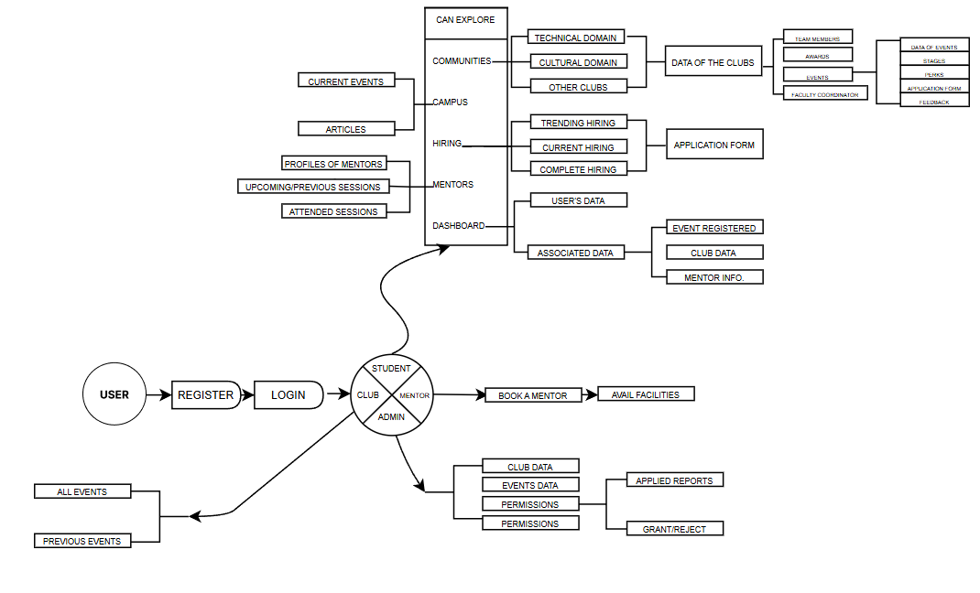

**REFER TO FLOW DIAGRAM**

Fig1. Flow Diagram

**RESULT**

The Edubridge platform successfully addresses the fragmentation in academic activities by providing a centralized and user-friendly solution for students, mentors, and educational institutions. The project demonstrated the effectiveness of an integrated academic ecosystem, allowing seamless access to events, seminars, competitions, and announcements.

Through the implementation process, Edubridge streamlined academic engagement by offering personalized recommendations, real-time collaboration tools, and an intuitive interface. The phased approach ensured continuous improvements, making the platform scalable and adaptable to evolving educational needs.

Key findings from this research confirm that:

[I] Edubridge enhances accessibility to academic opportunities  
[II] Improves collaboration among students

and mentors.  
[III] Reduces inefficiencies caused by

dispersed information.  
[IV] Encourages active participation in academic events.

This study establishes Edubridge as an innovative tool that not only simplifies academic activity management but also fosters a connected and interactive educational ecosystem. Future improvements may explore AI-driven analytics, multilingual support, and advanced engagement metrics to further enhance its impact.

**CONCLUSION**

Edubridge represents a promising solution to the challenge of fragmented academic engagement by providing a centralized platform that fosters collaboration, enhances accessibility, and promotes meaningful interactions within the educational ecosystem. By consolidating academic activities such as events, seminars, competitions, and announcements into a unified and user-friendly interface, Edubridge addresses the inefficiencies caused by the dispersion of information across multiple platforms.

Through its innovative use of technology, including AI-powered personalized recommendations, real-time collaboration tools, and a responsive design framework, Edubridge bridges the gap between students, mentors, and institutions. It simplifies the process of discovering, participating in, and managing academic engagements, making it an indispensable tool for modern education.

The phased development approach ensures that Edubridge evolves continuously, incorporating user feedback and adapting to the dynamic needs of the educational environment. This iterative strategy not only guarantees platform improvement but also enables it to stay relevant in the ever-changing landscape of education technology.

Beyond its immediate functionality, Edubridge has the potential to transform the academic experience by fostering a culture of collaboration, inclusivity, and active participation. For students, it offers a tailored and accessible gateway to academic opportunities. For mentors, it simplifies guidance and communication. For institutions, it streamlines the organization and promotion of events, ensuring a more efficient and cohesive academic management process.

**FUTURE SCOPE**

As technology continues to advance, Edubridge holds the promise of further growth and enhancement. Future iterations could explore: Leveraging blockchain for secure credential verification, AR/VR for immersive learning experiences, and advanced AI models for deeper personalization. Expanding access to users in low-connectivity areas, ensuring inclusivity across diverse regions. Customizing the platform to accommodate multilingual and multicultural contexts, facilitating its adoption by international educational institutions. Introducing dashboards for institutions to track performance metrics and insights on academic engagement trends. Enhancing user motivation and participation through game-like elements such as leaderboards and rewards.

In conclusion, Edubridge is not just a project; it is a vision for a connected, efficient, and inclusive educational ecosystem. By addressing the core challenges of academic fragmentation, it paves the way for a future where education is more accessible, engaging, and impactful for all stakeholders.

**REFERENCES**

[I]. **Kenge, Rohit. (2020).** A Research Study on the ERP System Implementation and Current Trends in ERP. **Shanlax International Journal of Management.** 8. 34-39. 10.34293/management.v8i2.3395.

[II]. **Tang, Hung-Lian & Chung, Sock & Se, Chun. (2009).** Examining the impact of possible antecedents on service usage: An empirical study on Macao e-government. EG. 6. 97-109. 10.1504/EG.2009.022595.

[III]. **Mahraz, Mohamed-Iliasse & Berrado, Abdelaziz & Benabbou, Loubna. (2019).** Success Factors for ERP Implementation: a Systematic Literature Review.

[IV]. **R. Patel and S. Gupta**, "Node.js: A Platform for Scalable Backend Development," IEEE Software, vol. 28, no. 3, pp. 22-33.

[V]. **Wang T, Li S**. Relationship between employment values and college students' choice intention of slow employment: A moderated mediation model. **Front Psychol**. 2022 Aug 11;13:940556.doi:10.3389/fpsyg.2022.940556. PMID: 36033039; PMCID: PMC9404505.

[VI]. **Saxena, Anant. (2013)**. Developing entrepreneurship and e-government in India: Role of common service centers**. Journal of E-Governance**. 36. 92-100. 10.3233/GOV-130340.

[VII]. **Azeta, Ambrose & Oyelami, Olufemi & Ayo, Charles. (2008).** Development of an E-learning web portal: The foss approach. The Turkish Online Journal of Distance Education.

[VIII]. Al-Mashari, M. 2003. Enterprise resource planning (ERP) systems: A research agenda. **Industrial Management & Data Systems,** Vol. 103/1, pp. 22-27.

[IX]. **Adeyinka, Tella & Bashorun, M.. (2011).** Impact of web portals on E-learning. 4th International Conference on the Applications of Digital Information and Web Technologies, **ICADIWT 2011**. 10.1109/ICADIWT.2011.6041424.

[X] **Al-Emran, M., Elsherif, H. M., & Shaalan, K. (2016).** Investigating Attitudes Toward the Use of Mobile Learning in Higher Education. **Computers in Human Behavior, 56**, 93-102.

[XI] **García-Peñalvo, F. J. (2021).** Digital Transformation in Higher Education: The Role of Learning Management Systems (LMS). **Education and Information Technologies, 26(4),** 4407–4430.

[XII] **Siemens, G. (2005).** Connectivism: A Learning Theory for the Digital Age. **International Journal of Instructional Technology and Distance Learning, 2(1).**

[XIII] **Dabbagh, N., & Kitsantas, A. (2012).** Personal Learning Environments, Social Media, and Self-Regulated Learning: A Natural Formula for Connecting Formal and Informal Learning. **The Internet and Higher Education, 15(1),** 3-8.

[XIV] **Wu, J. H., & Wang, Y. M. (2006).** Measuring User Satisfaction in Digital Learning Systems. **Computers & Education, 50(3),** 693-705.

[XV] **Pappas, C. (2015).** The Top eLearning Statistics and Facts for 2021 You Need to Know. **eLearning Industry.**

[XVI] **Anderson, T., & Dron, J. (2011).** Three Generations of Distance Education Pedagogy. **The International Review of Research in Open and Distributed Learning, 12(3),** 80-97.

[XVII] **Bower, M. (2019).** Technology-Mediated Learning Theory. **British Journal of Educational Technology, 50(3),** 1035-1048.